实验7 数据绑定控件的使用
实验类型：设计性实验 要求：必做 学时：4
实验时间及地点：

实验目的
1、掌握数据源控件的使用；
2、掌握GridView控件的使用；
3、掌握ListView控件的使用；
4、掌握控件DataList和Repeater的用法；
实验内容
1、数据记录的编辑与删除；
2、显示主表与从表；
3、使用DataList控件绑定数据并实现分页；
4、Repeater控件的使用；
5、ListView控件的使用；
6、将XML文件中数据绑定到GridView控件。
实验步骤
1、新建ASP.NET空网站。
2、使用数据源控件与GridView控件，实现数据记录的编辑与删除。
1）新建窗体页面，向页面中添加一个GridView控件，单击其智能按钮，新建数据源。
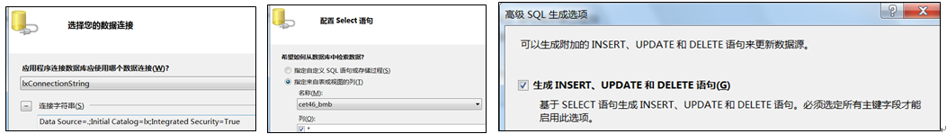
2）启用分页、编辑、删除。
3）设置PageSize的值为4。
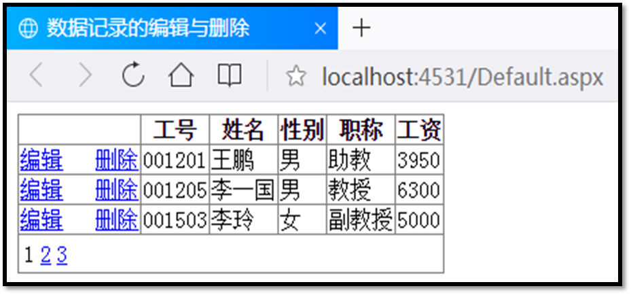
4）浏览页面。
把运行结果截图贴到实验报告本上。
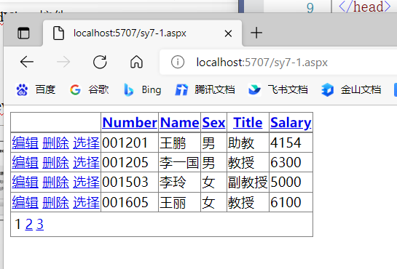
<%@ Page Language="C#" AutoEventWireup="true" CodeFile="sy7-1.aspx.cs" Inherits="sy7_1" %>

<!DOCTYPE html>

<html xmlns="http://www.w3.org/1999/xhtml">
<head runat="server">
<meta http-equiv="Content-Type" content="text/html; charset=utf-8"/>
<title></title>
</head>
<body>
<form id="form1" runat="server">
<div>
<asp:GridView ID="GridView1" PageSize="4" runat="server" AllowPaging="True" AllowSorting="True" AutoGenerateColumns="False" DataKeyNames="Number" DataSourceID="SqlDataSource1" OnSelectedIndexChanged="GridView1_SelectedIndexChanged">
<Columns>
<asp:CommandField ShowDeleteButton="True" ShowEditButton="True" ShowSelectButton="True" />
<asp:BoundField DataField="Number" HeaderText="Number" ReadOnly="True" SortExpression="Number" />
<asp:BoundField DataField="Name" HeaderText="Name" SortExpression="Name" />
<asp:BoundField DataField="Sex" HeaderText="Sex" SortExpression="Sex" />
<asp:BoundField DataField="Title" HeaderText="Title" SortExpression="Title" />
<asp:BoundField DataField="Salary" HeaderText="Salary" SortExpression="Salary" />
</Columns>
</asp:GridView>
<asp:SqlDataSource ID="SqlDataSource1" runat="server" ConflictDetection="CompareAllValues" ConnectionString="<%$ ConnectionStrings:testConnectionString %>" DeleteCommand="DELETE FROM [staff] WHERE [Number] = @original_Number AND (([Name] = @original_Name) OR ([Name] IS NULL AND @original_Name IS NULL)) AND (([Sex] = @original_Sex) OR ([Sex] IS NULL AND @original_Sex IS NULL)) AND (([Title] = @original_Title) OR ([Title] IS NULL AND @original_Title IS NULL)) AND (([Salary] = @original_Salary) OR ([Salary] IS NULL AND @original_Salary IS NULL))" InsertCommand="INSERT INTO [staff] ([Number], [Name], [Sex], [Title], [Salary]) VALUES (@Number, @Name, @Sex, @Title, @Salary)" OldValuesParameterFormatString="original_{0}" SelectCommand="SELECT [Number], [Name], [Sex], [Title], [Salary] FROM [staff]" UpdateCommand="UPDATE [staff] SET [Name] = @Name, [Sex] = @Sex, [Title] = @Title, [Salary] = @Salary WHERE [Number] = @original_Number AND (([Name] = @original_Name) OR ([Name] IS NULL AND @original_Name IS NULL)) AND (([Sex] = @original_Sex) OR ([Sex] IS NULL AND @original_Sex IS NULL)) AND (([Title] = @original_Title) OR ([Title] IS NULL AND @original_Title IS NULL)) AND (([Salary] = @original_Salary) OR ([Salary] IS NULL AND @original_Salary IS NULL))">
<DeleteParameters>
<asp:Parameter Name="original_Number" Type="String" />
<asp:Parameter Name="original_Name" Type="String" />
<asp:Parameter Name="original_Sex" Type="String" />
<asp:Parameter Name="original_Title" Type="String" />
<asp:Parameter Name="original_Salary" Type="Double" />
</DeleteParameters>
<InsertParameters>
<asp:Parameter Name="Number" Type="String" />
<asp:Parameter Name="Name" Type="String" />
<asp:Parameter Name="Sex" Type="String" />
<asp:Parameter Name="Title" Type="String" />
<asp:Parameter Name="Salary" Type="Double" />
</InsertParameters>
<UpdateParameters>
<asp:Parameter Name="Name" Type="String" />
<asp:Parameter Name="Sex" Type="String" />
<asp:Parameter Name="Title" Type="String" />
<asp:Parameter Name="Salary" Type="Double" />
<asp:Parameter Name="original_Number" Type="String" />
<asp:Parameter Name="original_Name" Type="String" />
<asp:Parameter Name="original_Sex" Type="String" />
<asp:Parameter Name="original_Title" Type="String" />
<asp:Parameter Name="original_Salary" Type="Double" />
</UpdateParameters>
</asp:SqlDataSource>
</div>
</form>
</body>
</html>

3、在同一页面中显示主表与从表，查询学生信息及其成绩信息。
1）新建窗体页面，分别向页面添加两个GridView控件，分别新建各自的数据源，主表选择学生表中的姓名、学号、性别字段，从表选择成绩表中的学号、课程名、成绩字段。注意设置GridView1的DataKeyNames属性为“学号”。
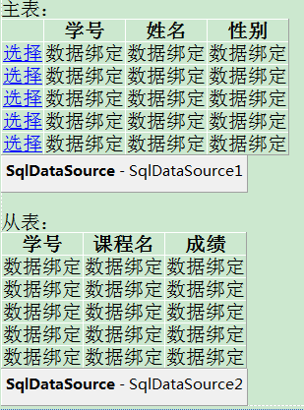
2）在GridView1中增加选择列，进一步配置GridView2的数据源，建立两个GridView控件之间的关联关系。单击Select语句配置中的“WHERE(W)”按钮，在“添加WHERE子句”对话框中按下图设置：
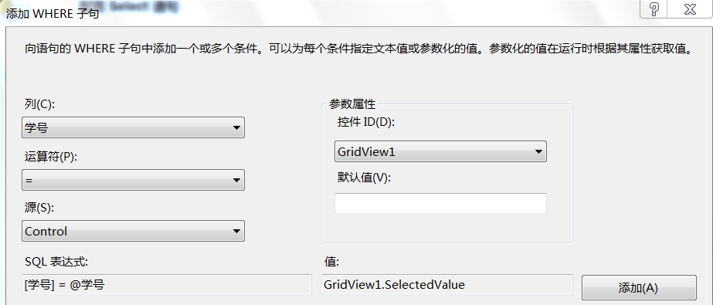
3）浏览页面。
把运行结果截图贴到实验报告本上。

<%@ Page Language="C#" AutoEventWireup="true" CodeFile="sy7-2.aspx.cs" Inherits="sy7_2" %>

<!DOCTYPE html>

<html xmlns="http://www.w3.org/1999/xhtml">
<head runat="server">
<meta http-equiv="Content-Type" content="text/html; charset=utf-8"/>
<title></title>
</head>
<body>
<form id="form1" runat="server">
<div>
<asp:GridView ID="GridView1" runat="server" AllowPaging="True" AllowSorting="True" AutoGenerateColumns="False" DataKeyNames="学号" DataSourceID="SqlDataSource1">
<Columns>
<asp:CommandField ShowSelectButton="True" />
<asp:BoundField DataField="学号" HeaderText="学号" ReadOnly="True" SortExpression="学号" />
<asp:BoundField DataField="姓名" HeaderText="姓名" SortExpression="姓名" />
<asp:BoundField DataField="性别" HeaderText="性别" SortExpression="性别" />
</Columns>
</asp:GridView>
<asp:SqlDataSource ID="SqlDataSource1" runat="server" ConnectionString="<%$ ConnectionStrings:testConnectionString %>" OldValuesParameterFormatString="original_{0}" SelectCommand="SELECT [学号], [姓名], [性别] FROM [学生]">
</asp:SqlDataSource>

<asp:GridView ID="GridView2" runat="server" AutoGenerateColumns="False" DataKeyNames="学号,课程名" DataSourceID="SqlDataSource2">
<Columns>
<asp:BoundField DataField="学号" HeaderText="学号" ReadOnly="True" SortExpression="学号" />
<asp:BoundField DataField="课程名" HeaderText="课程名" ReadOnly="True" SortExpression="课程名" />
<asp:BoundField DataField="成绩" HeaderText="成绩" SortExpression="成绩" />
</Columns>
</asp:GridView>
<asp:SqlDataSource ID="SqlDataSource2" runat="server" ConflictDetection="CompareAllValues" ConnectionString="<%$ ConnectionStrings:testConnectionString %>" DeleteCommand="DELETE FROM [成绩] WHERE [学号] = @original_学号 AND [课程名] = @original_课程名 AND (([成绩] = @original_成绩) OR ([成绩] IS NULL AND @original_成绩 IS NULL))" InsertCommand="INSERT INTO [成绩] ([学号], [课程名], [成绩]) VALUES (@学号, @课程名, @成绩)" OldValuesParameterFormatString="original_{0}" SelectCommand="SELECT [学号], [课程名], [成绩] FROM [成绩] WHERE ([学号] = @学号)" UpdateCommand="UPDATE [成绩] SET [成绩] = @成绩 WHERE [学号] = @original_学号 AND [课程名] = @original_课程名 AND (([成绩] = @original_成绩) OR ([成绩] IS NULL AND @original_成绩 IS NULL))">
<DeleteParameters>
<asp:Parameter Name="original_学号" Type="String" />
<asp:Parameter Name="original_课程名" Type="String" />
<asp:Parameter Name="original_成绩" Type="Int16" />
</DeleteParameters>
<InsertParameters>
<asp:Parameter Name="学号" Type="String" />
<asp:Parameter Name="课程名" Type="String" />
<asp:Parameter Name="成绩" Type="Int16" />
</InsertParameters>
<SelectParameters>
<asp:ControlParameter ControlID="GridView1" Name="学号" PropertyName="SelectedValue" Type="String" />
</SelectParameters>
<UpdateParameters>
<asp:Parameter Name="成绩" Type="Int16" />
<asp:Parameter Name="original_学号" Type="String" />
<asp:Parameter Name="original_课程名" Type="String" />
<asp:Parameter Name="original_成绩" Type="Int16" />
</UpdateParameters>
</asp:SqlDataSource>
</div>
</form>
</body>
</html>
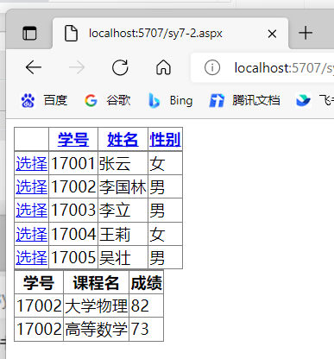
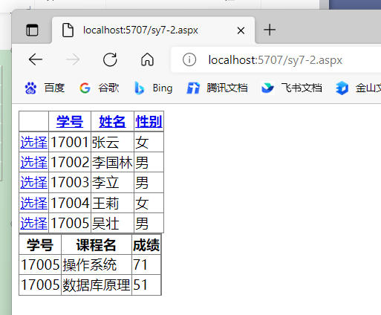
4、使用DataList控件绑定数据并实现分页。
1）新建窗体页面，在页面中添加一个DataList控件，设计其项模板。在DataList1控件的下面添加一个DIV，在其中添加2个Label控件和4个LinkButton控件，两个Label控件。
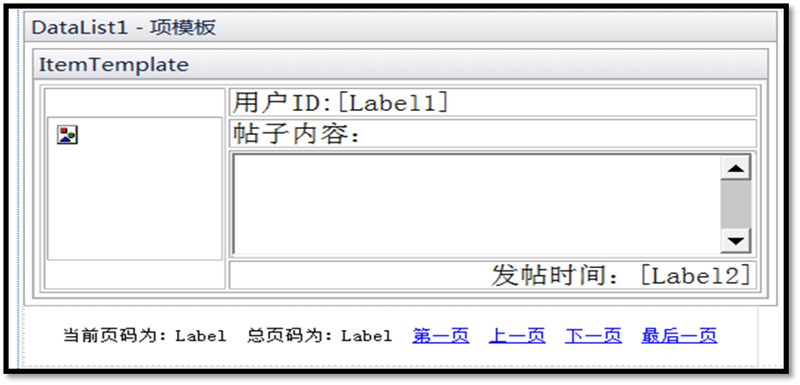
2）自定义方法dlBind()从数据表post中查询记录绑定到DataList1控件，然后通过设置PagedDataSource类来实现DataList控件的分页功能。
3）浏览页面。
把关键代码填写到实验报告本上，并把运行结果截图贴到实验报告本上。

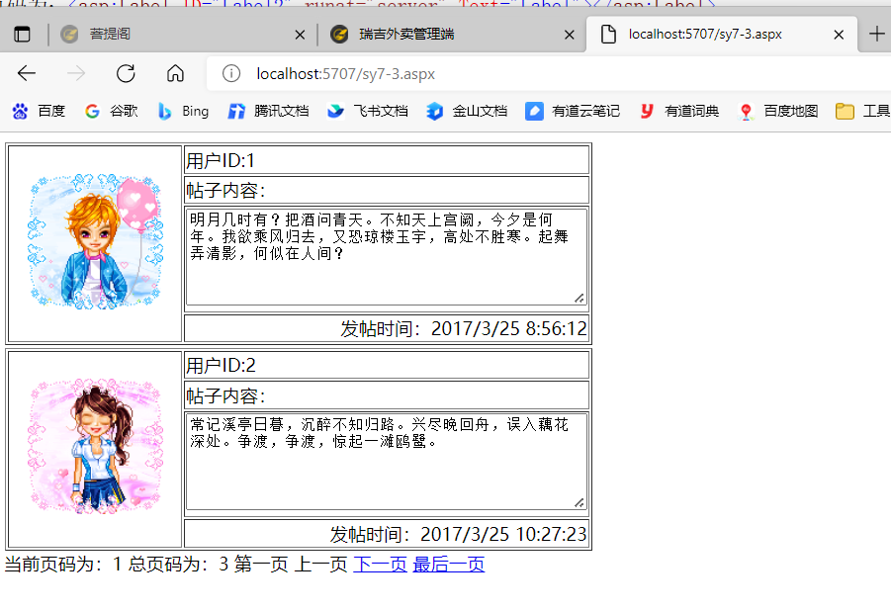
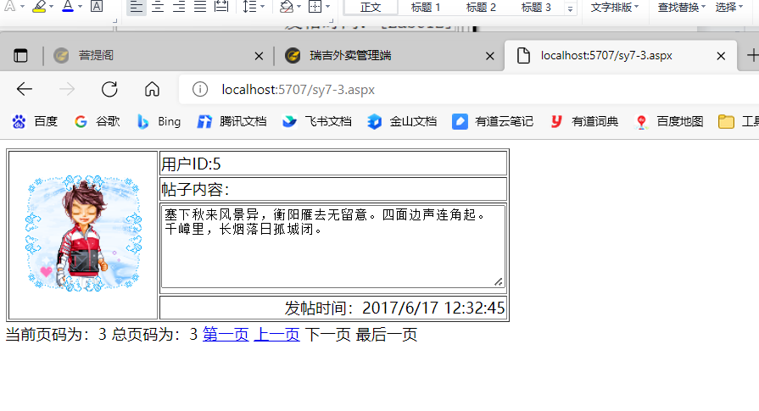
<%@ Page Language="C#" AutoEventWireup="true" CodeFile="sy7-3.aspx.cs" Inherits="sy7_3" %>

<!DOCTYPE html>

<html xmlns="http://www.w3.org/1999/xhtml">
<head runat="server">
<meta http-equiv="Content-Type" content="text/html; charset=utf-8"/>
<title></title>
</head>
<body>
<form id="form1" runat="server">
<div>
<asp:DataList ID="DataList1" runat="server">
<ItemTemplate>
<table border="1">
<tr>
<td rowspan="4" style="width: 150px; vertical-align: middle; text-align: center;">
<asp:Image ID="Image1" runat="server" Height="120px" Width="120px" ImageUrl='<%#Eval("photo") %>'/>
</td>
<td style="width: 350px">用户ID:<asp:Label ID="Label1" runat="server" Text='<%#Eval("id") %>'></asp:Label>
</td>
</tr>
<tr>
<td style="width: 350px">帖子内容：</td>
</tr>
<tr>
<td>
<asp:TextBox ID="TextBox1" runat="server" Height="80px" TextMode="MultiLine" Width="350px" Text='<%#Eval("contents") %>'></asp:TextBox>
</td>
</tr>
<tr>
<td style="text-align: right">发帖时间：<asp:Label ID="Label2" runat="server" Text='<%#Eval("postTime") %>'></asp:Label>
</td>
</tr>
</table>
</ItemTemplate>
</asp:DataList>
<div>
当前页码为：<asp:Label ID="Label1" runat="server" Text="Label"></asp:Label>
总页码为：<asp:Label ID="Label2" runat="server" Text="Label"></asp:Label>
<asp:LinkButton ID="LinkButton1" runat="server" OnClick="LinkButton1_Click">第一页</asp:LinkButton>
<asp:LinkButton ID="LinkButton2" runat="server" OnClick="LinkButton2_Click">上一页</asp:LinkButton>
<asp:LinkButton ID="LinkButton3" runat="server" OnClick="LinkButton3_Click">下一页</asp:LinkButton>
<asp:LinkButton ID="LinkButton4" runat="server" OnClick="LinkButton4_Click">最后一页</asp:LinkButton>
</div>
</div>
</form>
</body>
</html>

using System;
using System.Collections.Generic;
using System.Configuration;
using System.Data;
using System.Data.SqlClient;
using System.Linq;
using System.Web;
using System.Web.UI;
using System.Web.UI.WebControls;

public partial class sy7_3 : System.Web.UI.Page
{
SqlConnection conn = new SqlConnection(ConfigurationManager.ConnectionStrings["testConnectionString"].ConnectionString);

protected void Page_Load(object sender, EventArgs e)
{
if (!IsPostBack)
{
this.Label1.Text = "1";
dlBind();
}

}

public void dlBind()
{
int curpage = Convert.ToInt32(this.Label1.Text);
PagedDataSource ps = new PagedDataSource();
conn.Open();
string sqlstr = "select * from post";
SqlDataAdapter da = new SqlDataAdapter(sqlstr, conn);
DataSet ds = new DataSet();
da.Fill(ds, "post");
conn.Close();
ps.DataSource = ds.Tables["post"].DefaultView;
ps.AllowPaging = true;
ps.PageSize = 2;
ps.CurrentPageIndex = curpage - 1;
this.LinkButton1.Enabled = true;
this.LinkButton2.Enabled = true;
this.LinkButton3.Enabled = true;
this.LinkButton4.Enabled = true;
if (curpage == 1)
{
this.LinkButton1.Enabled = false;
this.LinkButton2.Enabled = false;
}
if (curpage == ps.PageCount)
{
this.LinkButton3.Enabled = false;
this.LinkButton4.Enabled = false;
}
this.Label2.Text = Convert.ToString(ps.PageCount);
this.DataList1.DataSource = ps;
this.DataList1.DataKeyField = "id";
this.DataList1.DataBind();
}
protected void LinkButton1_Click(object sender, EventArgs e)
{
this.Label1.Text = "1";
this.dlBind();
}
protected void LinkButton2_Click(object sender, EventArgs e)
{
this.Label1.Text = Convert.ToString(Convert.ToInt32(this.Label1.Text) - 1);
this.dlBind();
}
protected void LinkButton3_Click(object sender, EventArgs e)
{
this.Label1.Text = Convert.ToString(Convert.ToInt32(this.Label1.Text) + 1);
this.dlBind();
}
protected void LinkButton4_Click(object sender, EventArgs e)
{
this.Label1.Text = this.Label2.Text;
this.dlBind();
}
}

5、Repeater控件的使用。
1）新建网页，在页面中添加一个Repeater控件，切换至源代码视图，定义页眉模板、项目模板及页脚模板。
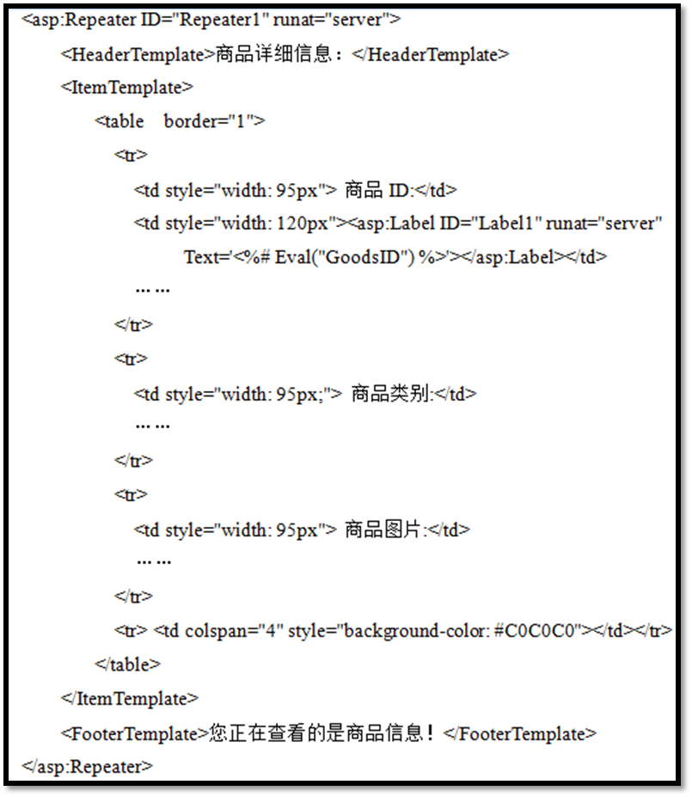
2）在Repeater 1控件的下面添加一个DIV，在其中添加2个Label控件和4个LinkButton控件。
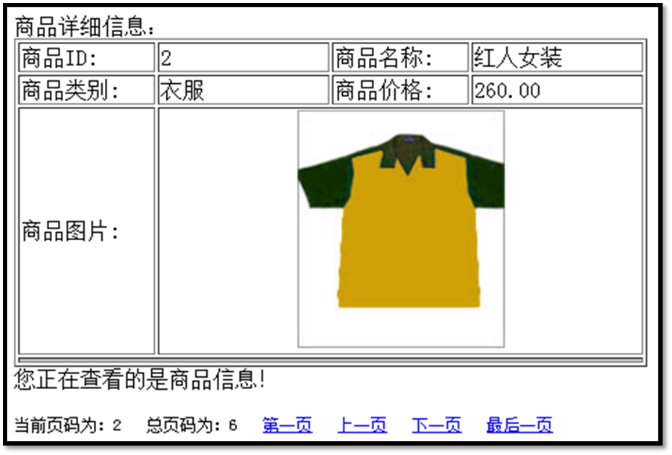
3）自定义方法rpBind()从数据表goods中查询记录绑定到Repeater 1控件。
4）浏览页面。
把关键代码填写到实验报告本上，并把运行结果截图贴到实验报告本上。
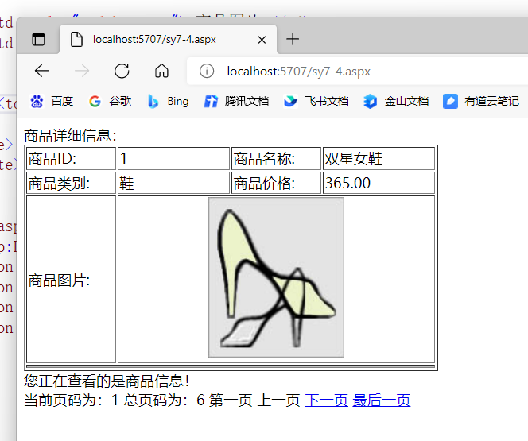
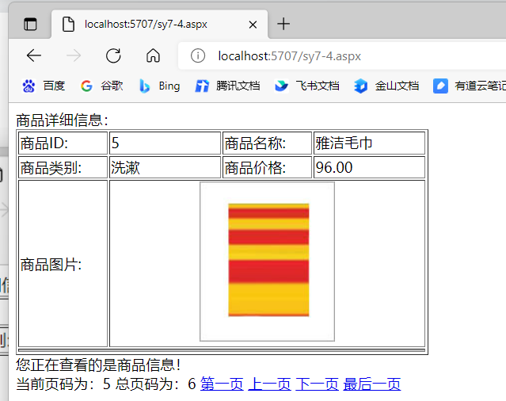
<%@ Page Language="C#" AutoEventWireup="true" CodeFile="sy7-4.aspx.cs" Inherits="sy7_4" %>

<!DOCTYPE html>

<html xmlns="http://www.w3.org/1999/xhtml">
<head runat="server">
<meta http-equiv="Content-Type" content="text/html; charset=utf-8"/>
<title></title>
</head>
<body>
<form id="form1" runat="server">
<div>
<asp:Repeater ID="Repeater1" runat="server">
<HeaderTemplate>商品详细信息：</HeaderTemplate>
<ItemTemplate>
<table border="1">
<tr>
<td style="width: 95px"> 商品ID:</td>
<td style="width: 120px">
<asp:Label ID="Label1" runat="server" Text='<%# Eval("GoodsID") %>'></asp:Label></td>
<td style="width: 95px"> 商品名称:</td>
<td style="width: 120px">
<asp:Label ID="Label2" runat="server" Text='<%# Eval("GoodsName") %>'></asp:Label></td>
</tr>
<tr>
<td style="width: 95px;"> 商品类别:</td>
<td style="width: 120px;">
<asp:Label ID="Label3" runat="server" Text='<%#Eval("GoodsTypeName") %>'></asp:Label></td>
<td style="width: 95px;">商品价格:</td>
<td style="width: 120px;">
<asp:Label ID="Label4" runat="server" Text='<%# Eval("GoodsPrice") %>'></asp:Label></td>
</tr>
<tr>
<td style="width: 95px"> 商品图片:</td>
<td colspan="3" style="text-align:center">
<asp:Image ID="Image1" runat="server" Width="150px" ImageUrl='<%#Eval("GoodsPhoto","~/images/{0}").ToString().Trim()%>'></asp:Image></td>
</tr>
<tr> <td colspan="4" style="background-color: #C0C0C0"></td></tr>
</table>
</ItemTemplate>
<FooterTemplate>您正在查看的是商品信息！</FooterTemplate>
</asp:Repeater>
<div>
当前页码为：<asp:Label ID="Label1" runat="server" Text="Label"></asp:Label>
总页码为：<asp:Label ID="Label2" runat="server" Text="Label"></asp:Label>
<asp:LinkButton ID="LinkButton1" runat="server" OnClick="LinkButton1_Click">第一页</asp:LinkButton>
<asp:LinkButton ID="LinkButton2" runat="server" OnClick="LinkButton2_Click">上一页</asp:LinkButton>
<asp:LinkButton ID="LinkButton3" runat="server" OnClick="LinkButton3_Click">下一页</asp:LinkButton>
<asp:LinkButton ID="LinkButton4" runat="server" OnClick="LinkButton4_Click">最后一页</asp:LinkButton>
</div>
</div>
</form>
</body>
</html>

using System;
using System.Collections.Generic;
using System.Configuration;
using System.Data;
using System.Data.SqlClient;
using System.Linq;
using System.Web;
using System.Web.UI;
using System.Web.UI.WebControls;

public partial class sy7_4 : System.Web.UI.Page
{
SqlConnection conn = new SqlConnection(ConfigurationManager.ConnectionStrings["testConnectionString"].ConnectionString);
protected void Page_Load(object sender, EventArgs e)
{
if (!IsPostBack)
{
this.Label1.Text = "1";
rpBind();
}
}

public void rpBind()
{
int curpage = Convert.ToInt32(this.Label1.Text);
PagedDataSource ps = new PagedDataSource();
conn.Open();
string sqlstr = "select * from goods";
SqlDataAdapter da = new SqlDataAdapter(sqlstr, conn);
DataSet ds = new DataSet();
da.Fill(ds, "goods");
conn.Close();
ps.DataSource = ds.Tables["goods"].DefaultView;
ps.AllowPaging = true;
ps.PageSize = 1;
ps.CurrentPageIndex = curpage - 1;
this.LinkButton1.Enabled = true;
this.LinkButton2.Enabled = true;
this.LinkButton3.Enabled = true;
this.LinkButton4.Enabled = true;
if (curpage == 1)
{
this.LinkButton1.Enabled = false;
this.LinkButton2.Enabled = false;
}
if (curpage == ps.PageCount)
{
this.LinkButton3.Enabled = false;
this.LinkButton4.Enabled = false;
}
this.Label2.Text = Convert.ToString(ps.PageCount);
this.Repeater1.DataSource = ps;
Repeater1.DataBind();
}
protected void LinkButton1_Click(object sender, EventArgs e)
{
this.Label1.Text = "1";
this.rpBind();
}
protected void LinkButton2_Click(object sender, EventArgs e)
{
this.Label1.Text = Convert.ToString(Convert.ToInt32(this.Label1.Text) - 1);
this.rpBind();
}
protected void LinkButton3_Click(object sender, EventArgs e)
{
this.Label1.Text = Convert.ToString(Convert.ToInt32(this.Label1.Text) + 1);
this.rpBind();
}
protected void LinkButton4_Click(object sender, EventArgs e)
{
this.Label1.Text = this.Label2.Text;
this.rpBind();
}
}

6、ListView控件的使用。
1）新建网页，在页面中添加一个ListView控件和一个SqlDataSource控件。
为SqlDataSource1配置数据源，选择staff表的所有列。在“高级SQL生成选项”对话框中勾选“生成INSERT、UPDATE和DELETE语句”。
2）选择SqlDataSource1作为ListView1控件的数据源。
3）配置ListView，选择布局、选择样式，并启用编辑、启用插入、启用删除、启用分页。
在源代码视图中找到DataPager控件，为其增加PageSize属性并把其值设为3。
4）在源代码视图中找到表头的定义代码，把表头的英文字段名称换成中文。
5）浏览页面。
把运行结果截图贴到实验报告本上。
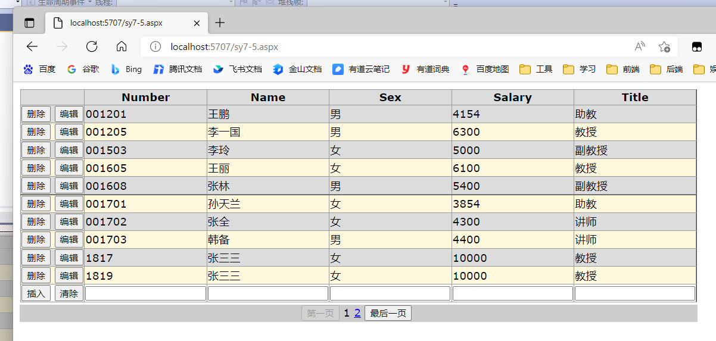
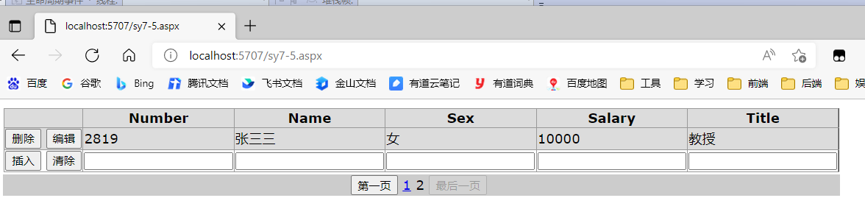

<%@ Page Language="C#" AutoEventWireup="true" CodeFile="sy7-5.aspx.cs" Inherits="sy7_5" %>

<!DOCTYPE html>

<html xmlns="http://www.w3.org/1999/xhtml">
<head runat="server">
<meta http-equiv="Content-Type" content="text/html; charset=utf-8"/>
<title></title>
</head>
<body>
<form id="form1" runat="server">
<div>
<asp:ListView ID="ListView1" runat="server" DataKeyNames="Number" DataSourceID="SqlDataSource1" InsertItemPosition="LastItem">
<AlternatingItemTemplate>
<tr style="background-color:#FFF8DC;">
<td>
<asp:Button ID="DeleteButton" runat="server" CommandName="Delete" Text="删除" />
<asp:Button ID="EditButton" runat="server" CommandName="Edit" Text="编辑" />
</td>
<td>
<asp:Label ID="NumberLabel" runat="server" Text='<%# Eval("Number") %>' />
</td>
<td>
<asp:Label ID="NameLabel" runat="server" Text='<%# Eval("Name") %>' />
</td>
<td>
<asp:Label ID="SexLabel" runat="server" Text='<%# Eval("Sex") %>' />
</td>
<td>
<asp:Label ID="SalaryLabel" runat="server" Text='<%# Eval("Salary") %>' />
</td>
<td>
<asp:Label ID="TitleLabel" runat="server" Text='<%# Eval("Title") %>' />
</td>
</tr>
</AlternatingItemTemplate>
<EditItemTemplate>
<tr style="background-color:#008A8C;color: #FFFFFF;">
<td>
<asp:Button ID="UpdateButton" runat="server" CommandName="Update" Text="更新" />
<asp:Button ID="CancelButton" runat="server" CommandName="Cancel" Text="取消" />
</td>
<td>
<asp:Label ID="NumberLabel1" runat="server" Text='<%# Eval("Number") %>' />
</td>
<td>
<asp:TextBox ID="NameTextBox" runat="server" Text='<%# Bind("Name") %>' />
</td>
<td>
<asp:TextBox ID="SexTextBox" runat="server" Text='<%# Bind("Sex") %>' />
</td>
<td>
<asp:TextBox ID="SalaryTextBox" runat="server" Text='<%# Bind("Salary") %>' />
</td>
<td>
<asp:TextBox ID="TitleTextBox" runat="server" Text='<%# Bind("Title") %>' />
</td>
</tr>
</EditItemTemplate>
<EmptyDataTemplate>
<table runat="server" style="background-color: #FFFFFF;border-collapse: collapse;border-color: #999999;border-style:none;border-width:1px;">
<tr>
<td>未返回数据。</td>
</tr>
</table>
</EmptyDataTemplate>
<InsertItemTemplate>
<tr style="">
<td>
<asp:Button ID="InsertButton" runat="server" CommandName="Insert" Text="插入" />
<asp:Button ID="CancelButton" runat="server" CommandName="Cancel" Text="清除" />
</td>
<td>
<asp:TextBox ID="NumberTextBox" runat="server" Text='<%# Bind("Number") %>' />
</td>
<td>
<asp:TextBox ID="NameTextBox" runat="server" Text='<%# Bind("Name") %>' />
</td>
<td>
<asp:TextBox ID="SexTextBox" runat="server" Text='<%# Bind("Sex") %>' />
</td>
<td>
<asp:TextBox ID="SalaryTextBox" runat="server" Text='<%# Bind("Salary") %>' />
</td>
<td>
<asp:TextBox ID="TitleTextBox" runat="server" Text='<%# Bind("Title") %>' />
</td>
</tr>
</InsertItemTemplate>
<ItemTemplate>
<tr style="background-color:#DCDCDC;color: #000000;">
<td>
<asp:Button ID="DeleteButton" runat="server" CommandName="Delete" Text="删除" />
<asp:Button ID="EditButton" runat="server" CommandName="Edit" Text="编辑" />
</td>
<td>
<asp:Label ID="NumberLabel" runat="server" Text='<%# Eval("Number") %>' />
</td>
<td>
<asp:Label ID="NameLabel" runat="server" Text='<%# Eval("Name") %>' />
</td>
<td>
<asp:Label ID="SexLabel" runat="server" Text='<%# Eval("Sex") %>' />
</td>
<td>
<asp:Label ID="SalaryLabel" runat="server" Text='<%# Eval("Salary") %>' />
</td>
<td>
<asp:Label ID="TitleLabel" runat="server" Text='<%# Eval("Title") %>' />
</td>
</tr>
</ItemTemplate>
<LayoutTemplate>
<table runat="server">
<tr runat="server">
<td runat="server">
<table id="itemPlaceholderContainer" runat="server" border="1" style="background-color: #FFFFFF;border-collapse: collapse;border-color: #999999;border-style:none;border-width:1px;font-family: Verdana, Arial, Helvetica, sans-serif;">
<tr runat="server" style="background-color:#DCDCDC;color: #000000;">
<th runat="server"></th>
<th runat="server">Number</th>
<th runat="server">Name</th>
<th runat="server">Sex</th>
<th runat="server">Salary</th>
<th runat="server">Title</th>
</tr>
<tr id="itemPlaceholder" runat="server">
</tr>
</table>
</td>
</tr>
<tr runat="server">
<td runat="server" style="text-align: center;background-color: #CCCCCC;font-family: Verdana, Arial, Helvetica, sans-serif;color: #000000;">
<asp:DataPager ID="DataPager1" runat="server">
<Fields>
<asp:NextPreviousPagerField ButtonType="Button" ShowFirstPageButton="True" ShowNextPageButton="False" ShowPreviousPageButton="False" />
<asp:NumericPagerField />
<asp:NextPreviousPagerField ButtonType="Button" ShowLastPageButton="True" ShowNextPageButton="False" ShowPreviousPageButton="False" />
</Fields>
</asp:DataPager>
</td>
</tr>
</table>
</LayoutTemplate>
<SelectedItemTemplate>
<tr style="background-color:#008A8C;font-weight: bold;color: #FFFFFF;">
<td>
<asp:Button ID="DeleteButton" runat="server" CommandName="Delete" Text="删除" />
<asp:Button ID="EditButton" runat="server" CommandName="Edit" Text="编辑" />
</td>
<td>
<asp:Label ID="NumberLabel" runat="server" Text='<%# Eval("Number") %>' />
</td>
<td>
<asp:Label ID="NameLabel" runat="server" Text='<%# Eval("Name") %>' />
</td>
<td>
<asp:Label ID="SexLabel" runat="server" Text='<%# Eval("Sex") %>' />
</td>
<td>
<asp:Label ID="SalaryLabel" runat="server" Text='<%# Eval("Salary") %>' />
</td>
<td>
<asp:Label ID="TitleLabel" runat="server" Text='<%# Eval("Title") %>' />
</td>
</tr>
</SelectedItemTemplate>
</asp:ListView>
<asp:SqlDataSource ID="SqlDataSource1" runat="server" ConflictDetection="CompareAllValues" ConnectionString="<%$ ConnectionStrings:testConnectionString %>" DeleteCommand="DELETE FROM [staff] WHERE [Number] = @original_Number AND (([Name] = @original_Name) OR ([Name] IS NULL AND @original_Name IS NULL)) AND (([Sex] = @original_Sex) OR ([Sex] IS NULL AND @original_Sex IS NULL)) AND (([Salary] = @original_Salary) OR ([Salary] IS NULL AND @original_Salary IS NULL)) AND (([Title] = @original_Title) OR ([Title] IS NULL AND @original_Title IS NULL))" InsertCommand="INSERT INTO [staff] ([Number], [Name], [Sex], [Salary], [Title]) VALUES (@Number, @Name, @Sex, @Salary, @Title)" OldValuesParameterFormatString="original_{0}" SelectCommand="SELECT [Number], [Name], [Sex], [Salary], [Title] FROM [staff]" UpdateCommand="UPDATE [staff] SET [Name] = @Name, [Sex] = @Sex, [Salary] = @Salary, [Title] = @Title WHERE [Number] = @original_Number AND (([Name] = @original_Name) OR ([Name] IS NULL AND @original_Name IS NULL)) AND (([Sex] = @original_Sex) OR ([Sex] IS NULL AND @original_Sex IS NULL)) AND (([Salary] = @original_Salary) OR ([Salary] IS NULL AND @original_Salary IS NULL)) AND (([Title] = @original_Title) OR ([Title] IS NULL AND @original_Title IS NULL))">
<DeleteParameters>
<asp:Parameter Name="original_Number" Type="String" />
<asp:Parameter Name="original_Name" Type="String" />
<asp:Parameter Name="original_Sex" Type="String" />
<asp:Parameter Name="original_Salary" Type="Double" />
<asp:Parameter Name="original_Title" Type="String" />
</DeleteParameters>
<InsertParameters>
<asp:Parameter Name="Number" Type="String" />
<asp:Parameter Name="Name" Type="String" />
<asp:Parameter Name="Sex" Type="String" />
<asp:Parameter Name="Salary" Type="Double" />
<asp:Parameter Name="Title" Type="String" />
</InsertParameters>
<UpdateParameters>
<asp:Parameter Name="Name" Type="String" />
<asp:Parameter Name="Sex" Type="String" />
<asp:Parameter Name="Salary" Type="Double" />
<asp:Parameter Name="Title" Type="String" />
<asp:Parameter Name="original_Number" Type="String" />
<asp:Parameter Name="original_Name" Type="String" />
<asp:Parameter Name="original_Sex" Type="String" />
<asp:Parameter Name="original_Salary" Type="Double" />
<asp:Parameter Name="original_Title" Type="String" />
</UpdateParameters>
</asp:SqlDataSource>
</div>
</form>
</body>
</html>

7、将XML文件中数据绑定到GridView控件。
1）新建XML文件。
2）新建网页，在页面中添加一个GridView控件， 设置其AllowPaging属性为True，PageSize属性为2。
3）自定义方法Bind()，用于从XML文件中读取数据信息，调用DataBind()方法对GridView控件进行绑定，并把列名换成中文。
3）浏览页面。
把关键代码填写到实验报告本上，并把运行结果截图贴到实验报告本上。
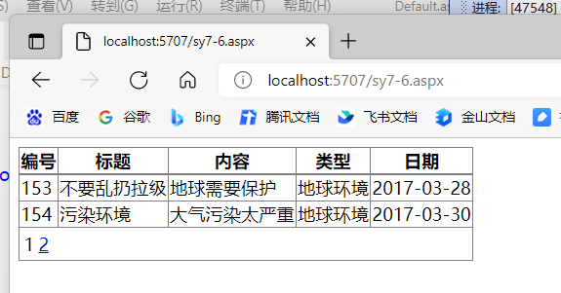
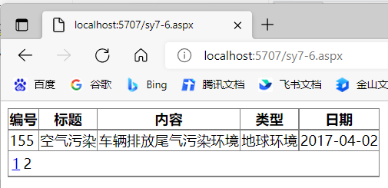
<%@ Page Language="C#" AutoEventWireup="true" CodeFile="sy7-6.aspx.cs" Inherits="sy7_6" %>

<!DOCTYPE html>

<html xmlns="http://www.w3.org/1999/xhtml">
<head runat="server">
<meta http-equiv="Content-Type" content="text/html; charset=utf-8"/>
<title></title>
</head>
<body>
<form id="form1" runat="server">
<div>
<asp:GridView ID="GridView1" AllowPaging="True" OnPageIndexChanging="GridView1_PageIndexChanging" PageSize="2" runat="server"></asp:GridView>
</div>
</form>
</body>
</html>

using System;
using System.Collections.Generic;
using System.Data;
using System.Linq;
using System.Web;
using System.Web.UI;
using System.Web.UI.WebControls;

public partial class sy7_6 : System.Web.UI.Page
{
protected void Page_Load(object sender, EventArgs e)
{
if (!IsPostBack)
{
Bind();
}
}

protected void Bind()
{
DataSet ds = new DataSet();
ds.ReadXml(Server.MapPath("news.xml"));
GridView1.DataSource = ds.Tables[0].DefaultView;
GridView1.DataBind();
GridView1.HeaderRow.Cells[0].Text = "编号";
GridView1.HeaderRow.Cells[1].Text = "标题";
GridView1.HeaderRow.Cells[2].Text = "内容";
GridView1.HeaderRow.Cells[3].Text = "类型";
GridView1.HeaderRow.Cells[4].Text = "日期";
}
protected void GridView1_PageIndexChanging(object sender, GridViewPageEventArgs e)
{
GridView1.PageIndex = e.NewPageIndex;
Bind();
}
}
实验小结
通过本次实验我学会ASP.NET中数据绑定控件的基本使用，能够使用控件展示数据库或者XML文件的内容，并能够根据文件的内容进行分页展示。

